**Spring 2017**

**ESI 5359**

**Industrial Financial Decisions**

**Yezehao Huai (5965823)**

**Chapter 8 Homework**

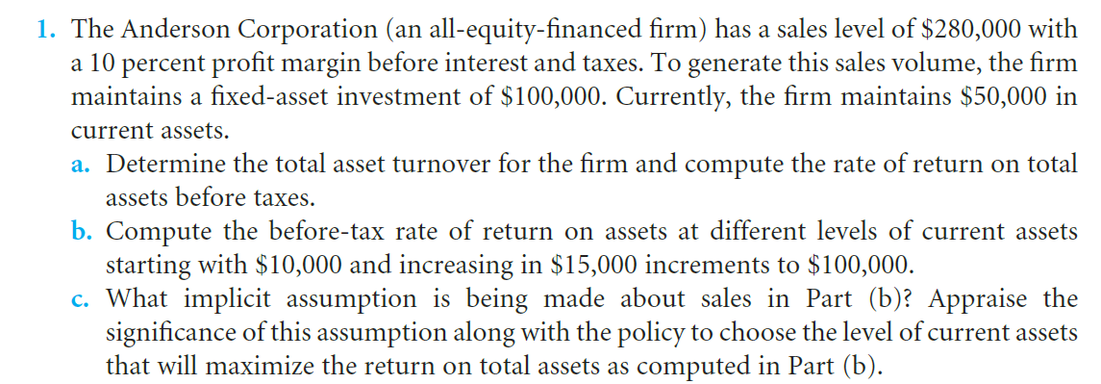

1. The total asset turnover is $280,000/($100,000+$50,000)=1.867

The rate of return on assets before taxes is

($280,000*10%) / ($100,000+$50,000) =18.67%

1. $280,000*10%=$28,000

$28,000/ ($10,000+$100,000) = 25.45%

$28,000/ ($25,000+$100,000) = 22.40%

$28,000/ ($40,000+$100,000) = 20.00%

$28,000/ ($55,000+$100,000) = 18.06%

$28,000/ ($70,000+$100,000) = 16.47%

$28,000/ ($85,000+$100,000) = 15.14%

$28,000/ ($100,000+$100,000) = 14.00%

1. The implicit assumption of Part (b) is that different levels of working capital has no influence to sales and costs. This assumption is very important for choosing the level because current assets have relationship with inventory and production materials. The inventory and production materials will influence the level of sales and costs

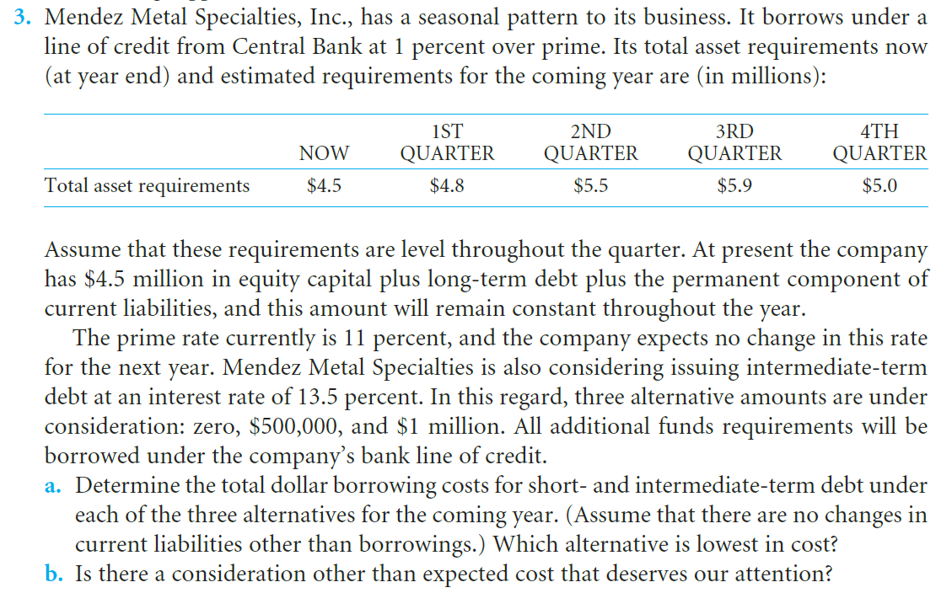

1. **The first alternative: zero**

1st quarter: ($4,800,000-$4,500,000)*(11%+1%)*0.25=$9,000

2st quarter: ($5,500,000-$4,500,000)*(11%+1%)*0.25=$30,000

3st quarter: ($5,900,000-$4,500,000)*(11%+1%)*0.25=$42,000

4st quarter: ($5,000,000-$4,500,000)*(11%+1%)*0.25=$15,000

Total borrowing costs: $96,000

**The second alternative: $500,000**

Loan cost: $500,000*13.5%= $67,500

1st quarter: 0

2st quarter: $500,000*(11%+1%)*0.25=$15,000

3st quarter: $900,000*(11%+1%)*0.25=$27,000

4st quarter: 0

Total borrowing costs: $109,500

**The third alternative: $1,000,000**

Loan cost: $1,000,000*13.5%= $135,000

1st quarter: 0

2st quarter: 0

3st quarter: $400,000*(11%+1%)*0.25=$12,000

4st quarter: 0

Total borrowing costs: $147,000

As the above, the first alternative is lowest in cost.

1. When we consider the alternative, we have to consider about the risk of in time repayment. The risk of repaying in time for the short-term loan is high. Use the long-term loan could reduce the risk but the total costs will be higher.